**How to add specific folder 17-18 from a folder and push inside a single folder on you github connected repo from your local machine**

* Create a new folder in github connected repo and move the specified files

* How to deal with the repository that is already connected to another github repo, because it is pushing the changes on the lastest connected one, thus we need to use **set-url**  command

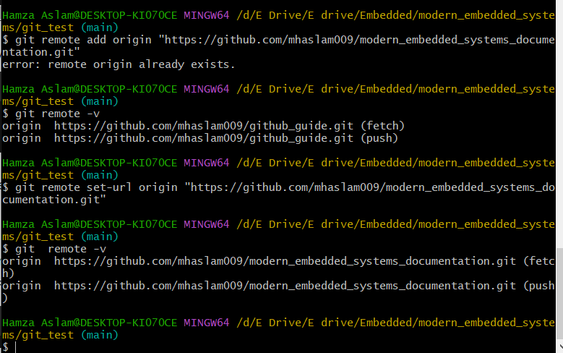

* Always remember, the newly added remote origin when pulling, it has no history then use **--allow-unrelated-histories** command

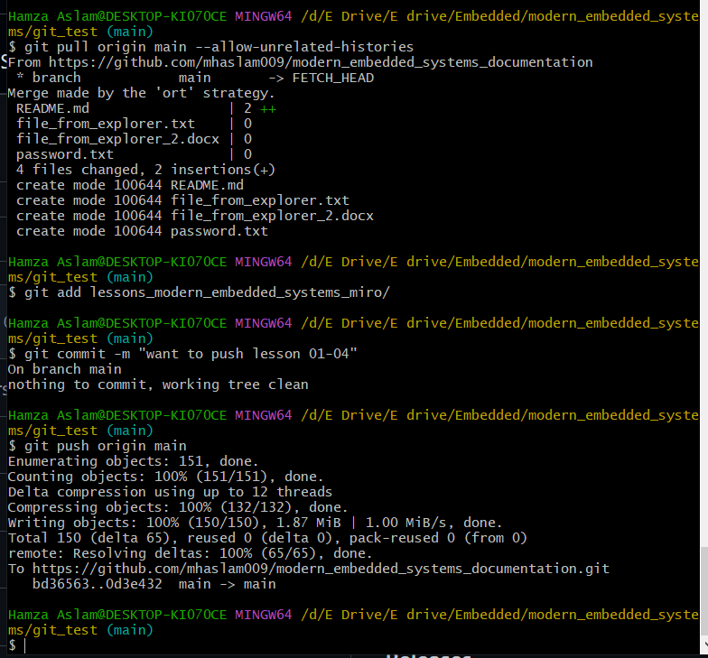

* Verification:

